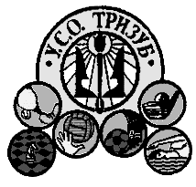
UKRAINIAN AMERICAN SPORT CENTER

Lower State and County Line Roads

P.O. Box 346

Horsham, PA. 19044

www.tryzub.org

Subject: Ukrainian Folk Festival
in Celebration of Ukraine’s Independence Day at the Ukrainian American Sport Center

To Potential Vendors:

The Ukrainian American Sports Center will once again be holding the Ukrainian Folk Festival Ukrainian Independence Day Celebrations at its Horsham facility on Sunday, August 25, 2013. The cost for each 12-foot wide slot will be $100. Please let us know if you are interested in taking part by filling out the application below. The application may be faxed, emailed or mailed to Bohdan Pazuniak, see blow.

All the best,

Bohdan Pazuniak
(609) 876-8372 voice
(215) 885-1942 fax
216Wyncote Road
Jenkintown ,PA 19046
Bohdanp216@comcast.net

Ukrainian American Sports Center – Ukrainian Independence Day Celebration
8/25/2013

Name of Organization/Institution/Company: ___________________________________
Contact Name: ___________________________________________________________
Address: _______________________________________________________________
Telephone: ______________________________________________________________
Email Address: ___________________________________________________________
Do you need electric service? ___ Yes ___ No
Other Requirements :______________________________________________________

